Deputy Chairman of the Council of Ministers of the Republic of Karakalpakstan for agriculture and water management

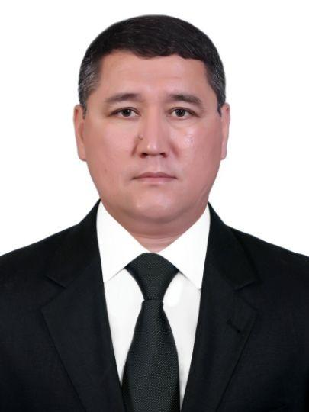

Kaypov Daryabay Jaksıbaevich

Аddress:

203103, Nukus, street Independence, 50

Phone:

0 (361) 222-46-00

E-xat:

d.kaypov@exat.uz

E-mail:

Reception days:

Friday 16:00-18:00

