The committee on Ecology and Environmental protection of the Karakalpakstan Republic.
The committee on Ecology and Environmental protectionof the Karakalpakstan Republic

­­­­­­­­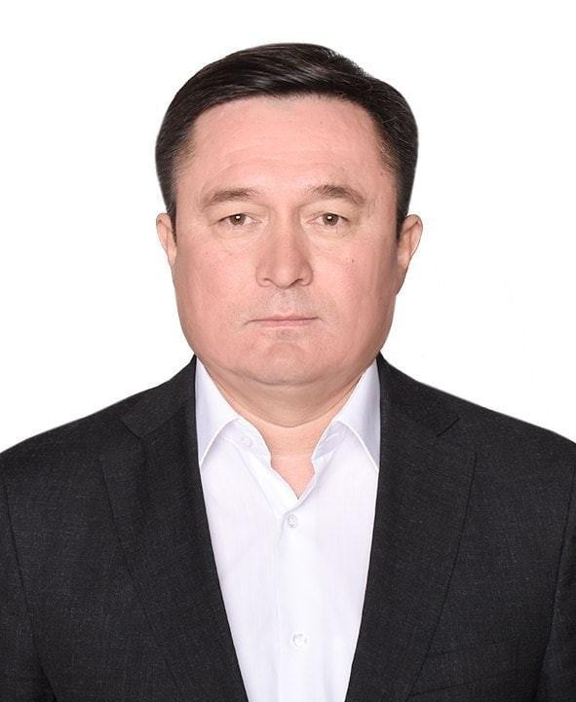
DjumaniyazovMaqsud Allanazarovich

Head of Karakalpakstan Ecology and environmentalprotection committee.

Location;

230100 , city of nukus , berdaq street , street no

Phone;

0(361) 224-19-51 0(361) 224-08-77

E-mail:

rktabiat@exat.uz nukus@uznature.uz

Acceptance dates;

Tuesday 09:00-13:00 15:00-1800
Positions of the Head of the Committee forEnvironmental Protection and Environment of the Republic of Karakalpakstan. Activity of the StateCommittee for Ecological and Environmental Protection of the Republic ofUzbekistan.

I. Common cases
1. The Committee on Ecology and EnvironmentProtection of the Republic of Karakalpakstan, in the course of its work, has established the "Regulation on State Committee forEcology and Environment Protection of the Republic of Uzbekistan" and "On Ecology and Environment Protection Committee of the Republic ofKarakalpakstan, other environmental protection"relevant regulations, rules and regulations.
2. Thehead of the Ecology and Environmental Protection Committee of the Republic ofKarakalpakstan has been appointed as Deputy Head of the State Committee forEcology and Environmental Protection of the Republic of Uzbekistan.
3. Isbased on the decision of the Presidium of the Supreme Soviet of the Republic ofKarakalpakstan and is assigned to the work.
4. Heis the chief state inspector of the Republic of Karakalpakstan, the head of theEcology and Environmental Protection Committee.
II. Job responsibilities.
1. TheEcology and Environmental Protection Committee of the Republic ofKarakalpakstan, the Working Group, the District Council of Elders, the State Ecological Expertise andEnvironmental Certification. TheCommittee of the Republic of Karakalpakstan is engaged in inspections in thecities and regions, the economy of nature use, workers, accounting, regulation,occupational workers, personal affairs and civic protection.
2. Stateof the Republic of Karakalpakstan State and public administration bodies, citizens'self-governing bodies, neighborhood authorities and other non-governmentalorganizations shall be guided by the principles of nature conservation and thestate's role in the implementation of inter-sectoral use of the environment andnatural resources.

3. TheRepublic of Karakalpakstan, in the area of economic and social development,endeavors to allocate resources and programs for the protection of theenvironment and the complex use, storage, reproduction of natural resources.
4. Theorganization will endeavor to provide guidance and guidance on the use ofenvironmental protection and the protection and use of natural resources. The work and process of the work on the protection ofthe environment and the complexutilization of natural resources will be coordinated by the enterprises,organizations and other natural resource users, and the implementation will beimplemented. Compensation laws for environmental pollution and environmentalpollution are permissible, and permits are granted on environmental protectionand use of natural resources.
5. Monitoringof soil, natural hazards, water, atmospheric air, flora and fauna iscoordinated, pollution of objects is the method of managing the analyticalinformation and environmental protection of natural resources and the harmfulimpact on natural resources.
6. Allotmentof land for all types of activity in the work of state committees on acceptanceand recycling of objects of nature protection, obtaining of objects of nature,is taken into the coordination of the documents.
7. Atthe same time, environmental education is promoted by the development ofscience and education, and the level of ecological education among youngpeople.
8. Establishingcomplex inspections of enterprises and catering services in compliance withnature conservation norms also saves it.
9. TheRepublic of Karakalpakstan, city and district nature protection inspections arerequired to be understood for non-service personnel.
10. TheState Committee for Ecology and Environmental Protection of the Republic ofUzbekistan shall have the right to make timely submission of labor orders,labor and production procedures and use less time.
11. Statisticalreporting by the State Committee for Ecology and Environmental Protection ofthe Republic of Uzbekistan and the Committee of the Republic of Karakalpakstanis completed and supplemented.
III. Rights
1. Incities and districts of the Republic of Karakalpakstan, businesses are givenposts to individuals and individuals who are physically dependent on natureconservation.
2. Inthe Karakalpakstan Republic, city and district subordinate enterprises, theCabinet of Ministers of the Republic of Uzbekistan and the Council of Ministersof the Republic of Karakalpakstan on the implementation of the economicmechanism for the protection of the environment and the environment arerequired to provide information on the delivery of compensation reports to theelderly elder.
3. Thework plans for the Karakalpakstan Republic, city and district inspectors havethe right to make proposals for proposals, as well as for their considerationof the cases and inspections.
4. Thepollution of nature entails damage to its legal and physical persons because ofthe use of resources without the use of intelligence.
5. Withthe help of his own authority, he documents the documents on the responsibilityof the khokimiyats for the protection of the environment and the environment,and the khokimiyats are based on the HRSU. The documents will be sent to lawenforcement agencies.
6. TheState Committee for Ecology and Natural Resources of the Republic of Uzbekistanis responsible for the creation of necessary facilities for the protection ofthe environments.
IV. KnowledgeRequirements.
1. Decrees,resolutions of the President of the Republic of Uzbekistan and the Decree ofthe High Council and the Supreme Council, decisions of the Cabinet of Ministersof the Republic of Karakalpakstan and the Council of Ministers of the Republicof Karakalpakstan State Committee for Ecology and Natural Resources and theCommittee of the Republic of Karakalpakstan regulations and normativedocuments, employees of the Labor Code of the Republic of Uzbekistan, shouldknow the working technology, certification, the relevant part of the ecologicalcode of the Criminal Code of the Republic of Uzbekistan, the companionship ofthe occupational safety and natural resource conservation businesstechnologies.
2. TheState Committee for Ecology and Environmental Protection of the Republic ofUzbekistan and the Ecological and Environmental Protection Committee of theRepublic of Karakalpakstan should be abolished.
3. Thefindings of the inquiry should contain little suggestions on how to look at thedocuments and the missing gaps.
4. Accordingto the provisions of the environmental protection regulations, the rule of lawshould be enforced, and the protocol for the offense should be based on theprinciple of strict adherence to the judiciary.
5. Inthe workplace, he must use his knowledge mostly.
6. Inorder to increase the knowledge on the subject, it is necessary to work on thebasis of methodological support and work on the smallest amount of work in thedevelopment of scientific knowledge.
V. Qualification requirements.
-High-profileis a must-have environmentalist. Ecology and Atrophic Protection should not beless than five years in the public administration body.

